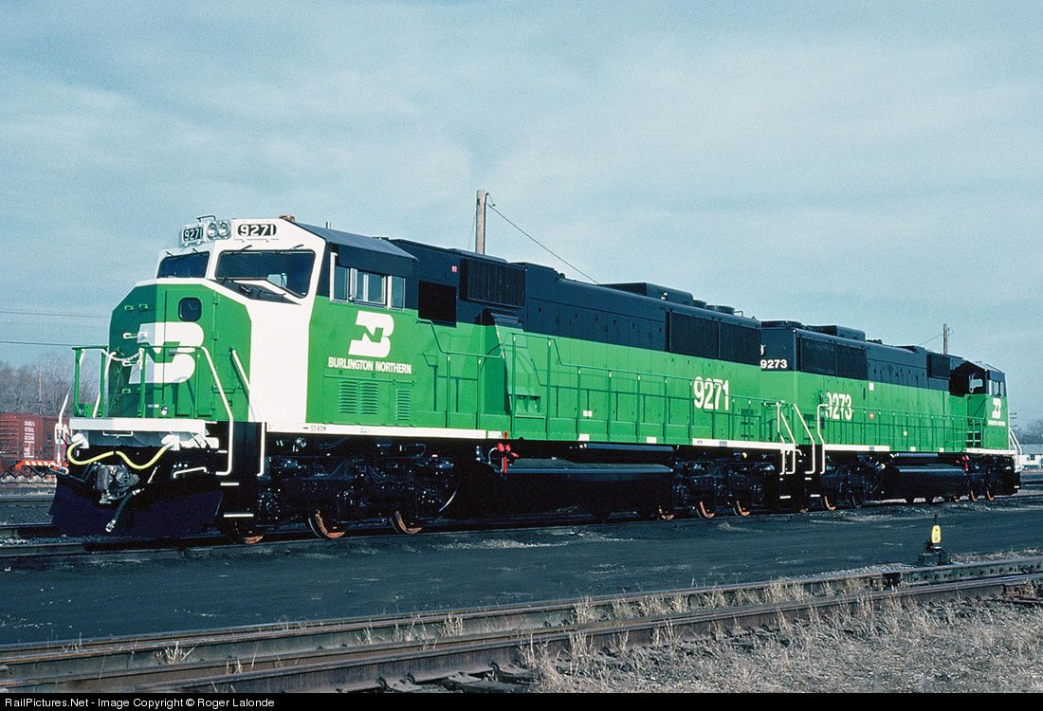

Burlington Northern

The Ares Decision

Samuel Akinfenwa | CIS 410 | September 1, 2020

**Table of Contents**

Introduction 2

Industry Competitive Analysis 3

Mission Statement

Generic Strategy

Organizational Structure

Porter Five Forces

Stakeholders 5

Problem 5

Recommendation 7

Work Cited 8

**Introduction**

The Burlington Northern (BN), formed in 1970, a vast rail system that owns natural substantial resources and diverse operations. The Railroad Company was a merger of four different railroads. In 1989, BN has up to 800 trains per day ran on its routes generating revenues of 4.606 billion and a net income of 242 million. BN had revenues from seven primary segments: coal, agricultural commodities, industrial products, intermodal, forest products, food and consumer products, intermodal, forest products, food, and consumer products, and automotive products. Coal was its largest source of revenue, generating almost one-third of total revenue. The second largest was Agricultural Commodities, especially grain.

The operations and Staff are headquartered in three cities. Corporate functions such as finance, strategic planning, marketing, and labor relations were in Fort Worth, Texas. The CEO and COO also. Operation Department that oversees the operating division and managed support functions were in Overland Park, Kansas. The corporate staff functions, such as information System Services, were in St. Paul, Minnesota.

In 1990, Burlington Railroad was considering an Information Technology solution and complex project that would improve its service, raise prices, and help meet its strategic goals. The long and complex is Advanced Railroad Electronics System), an automated railroad control system worth up to $350 million.

**Industry Competitive Analysis**

Burlington Northern competes in transportation industry were the footprint is set by BN business decisions. BN faces little competitive rivalry, threats of new entrants, and bargaining power of supplier or customers. BN faces some competition in railroad industry from companies that implement new and efficient technology.

MISSION STATEMENT

Burlington Northern is a transportation company that uses the most advance, cost efficient and quickest way of ensuring goods are delivered and provide an operating service better than its competitors.

GENERIC STRATEGY

Burlington Northern business strategy is cost leadership due to large amount of goods delivered and low time sensitivity. BN is also always look to reduce the cost of its transportation. Therefore, the ARES project was in consideration. By delivering more goods at a lower cost, BN achieves economies of scale.

ORGANIZATIONAL STRUCTURE

“We can explore the idea that organization is itself a cultural Phenomenon that varies according to a society stage of development” (Morgan). The company is allows trying to move with society and get ahead of its competitors.

PORTER’S FIVE FORCES

**Competitive Rivalry:**Burlington Northern Railway's biggest rival is Union Pacific, according to the case. The competitive rivalry is strong, but it is not a concern. Low

**The threat of New Entrants:**As a result of four railroad merging, Burlington Railroad faces low threats from new entrants. A new company would require massive capital and resources. Since Railroad companies own rails it will be difficult to compete. Low

**The Threat of Substitutes:**The goods carried on the trains are inexpensive and incentive to time, so goods that are sensitive to time will be carried by the truck companies. Other transportation is easier to track, customers might prefer trucks or airplanes to ship expensive goods. High

**Bargaining Power of Suppliers:**Segments covered by other transportation like the trucks and airways industries; the railroad industry cannot compete with them. So, the railroad industry is highly competitive with its segments. Burlington Northern compete with other railroads for customer and markets. High

**Bargaining Power of Customers:**The transportation market is mostly determined by segments. Customer bargaining power is limited but essential. If the Burlington Northern is not competing with it rival in its industry, based on customer pricing and satisfaction it could lose customers. Medium

**StakeHolders**

**Employees:** Burlington Northern employees includes the conductors, consultants, dispatchers, office personnel and maintenance crews. They have a huge stake in the company’s operations and services.

**Customers:** The Burlington Northern customers are affected by the company’s operations and services.

**Shareholders:** Investors in Burlington Northern have a huge stake in the company’s decision making. The implementation of ARES has raised some concern about the company’s future from its shareholders.

**Problem**

**Implementing ARES:**Implementing ARES in Burlington northern is an investment that will extensively change the BN organization**.**ARES, a full command, control, communications, and information systems that would enable BN to gain additional control over its operations, would be a brand-new change and revolution in the railroad industry. ARES is will allow Burlington Northern to branch into other segment markets and compete with other transportation industries. ARES uses a high-speed computing, digital communications, and state of the art electronics that generate efficient traffic plans, the plans show the movement for individual trains this is done by knowing the position and speed of trains and other equipment on the tracks. This is will be a massive help for dispatchers who lack information on the train's movement.

There is a large investment of $350 million, a control center worth $80 million, the data link costs $80 million, and On-board equipment worth $200 million. There is a high potential benefit with uncertainty because the benefit depends on the implementation success. The estimated gross benefit is in the range of $400 million to $900 million, with a present value of about $600 million. The implementation carries a lot of risks, but a successful implementation will increase the service and provide better-operating efficiency.

Effect on stakeholders

**Customers:**Burlington Northern Customers will have an improved customer service with reduced costs due to the largest component of benefit concluded by the ARES team, Revenue Enhancements

**Employees:**Burlington Northern Employees will affect by the new ARES system; dispatchers will see an increase in productivity. With Damage Prevention, a benefit of ARES, the maintenance and repair crews will have lesser responsibility. This could lead to fewer jobs in those departments and new opportunity in the ARES team

**Shareholders:**An increase in stock value for the shareholder is expected if investors see Burlington Northern ARES system as a potential industry leader. Investors will be willing to invest in Burlington Northern as an innovative, culture-changing company.

**RECOMMENDATION**

If I was an executive in Burlington Northern team, I will highly support the development of the ARES project. Doing nothing could help rivals get ahead. BN needs to remain competitive against its competition, but it needs direction and a management team that is willing to embrace the change. The project is vital in determining the company’s future and it could shape the company for the better or worse. BN culture as a potential and organization changer to work with. The ARES project is not just a new technology, according to the COO, but a new business process that will change the operation and a complete redesign of the operating position.

CItations

Morgan, Gareth. Images of Organization: International Version. Thousand Oaks, CA: SAGE Publications, 1997. Print. Pg 116.